Omega Exploration Map - Diodes

Please fill out the following sections of your map for your project. Many of you will learn skills or concepts that are beyond the Intro to ECSE concept list. Please provide references, links to website, pictures or screenshots of how you explored in your project!

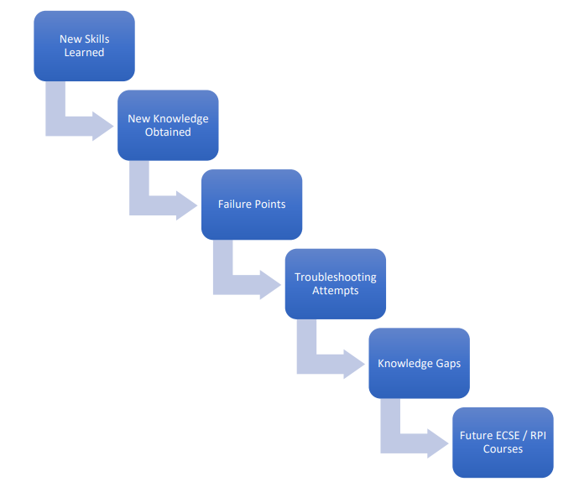

Contents

What is the Purpose of a Clean Room? 1

How is this Related to ECSE? 1

Survey – Clean Room Equipment 2

In-Depth Exploration – Clean Room Equipment 2

Knowledge Gaps 3

Future ECSE/RPI Courses 3

# What is the Purpose of a Clean Room?

*What goes on in clean rooms? What is made there?*

# How is this Related to ECSE?

*The diagram to the right shows the 6 main areas into which topics in ECSE are divided. In which of the 6 areas do you think clean rooms play an important role? Why?*

# Survey – Clean Room Equipment

*Identify three pieces of equipment that you saw while in the clean room. Very briefly, describe what each of them is used for.*

# In-Depth Exploration – Clean Room Equipment

*Choose one of the above pieces of equipment and describe what it does, how it works (to the best of your knowledge), and how it is related to the process of creating a diode. This will also be part of your presentation.*

# Knowledge Gaps

*What things on your clean room tour did you not understand*?

# Future ECSE/RPI Courses

*Which course(s) at RPI do you think would help you fill in the knowledge gaps that you listed above? And why?*

Exploration Map Grading

**Exploration Map Standards**

1. **Exploration Completed**